Solar Roads Could Power An Entire Country
May 12, 2014 | by Justine Alford
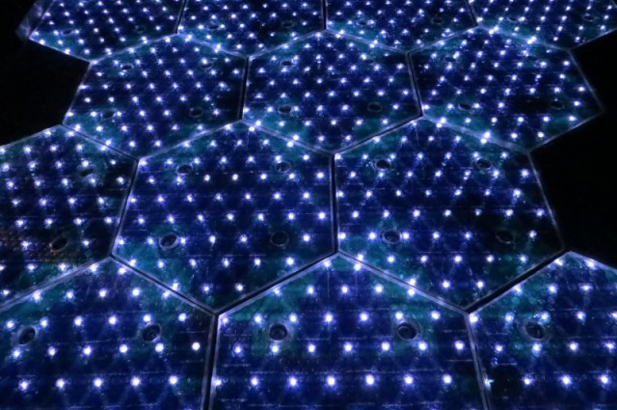photo credit: Solar Roadways
Share125K Tweet1K 65 Reddit16 288
A small US-based company called Solar Roadways are developing a solar road surface that, if installed nationwide, has the potential to produce more renewable energy than the entire country uses. In fact, they’ve actually already developed a working prototype that’s been installed in a parking lot, and they’re now crowdsourcing funds in order to tweak the design and move towards production.
Solar Roadways, which was started by Scott and Julie Brusaw in 2006, designed and developed hexagonal glass solar panels studded with LED lights that could be installed on a variety of surfaces such as roads, pavements and playgrounds. These panels would more than pay for themselves and would benefit both businesses and homeowners as the energy generated from driveways and parking lots could be used to power buildings, and any excess can be sold back to the grid.
The panels also contain heating elements to melt ice and snow so are ideal in winter conditions, and LEDs to make road lines and signs which have been previously shown to reduce night time accidents. The surface could also be used to charge electric vehicles as oppose to fossil fuels, and future technology could even allow for charging whilst driving via mutual induction panels. Amazingly, the team also found that car headlights can produce energy in the panels, so cars driving around at night would be producing some electricity.
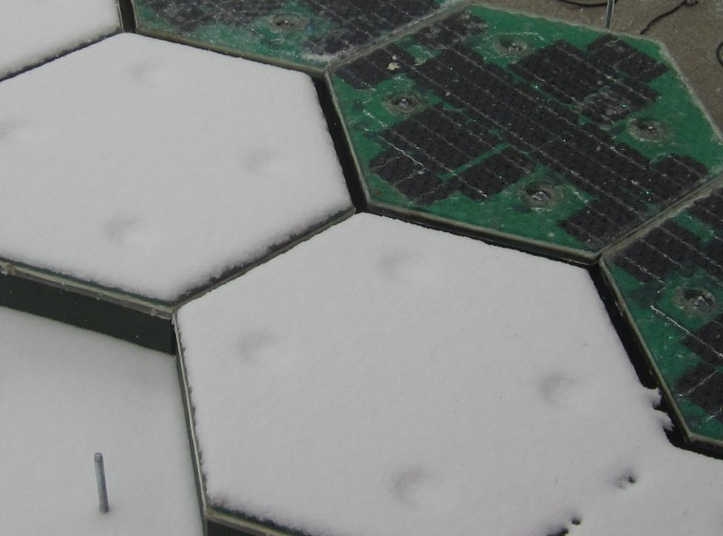
Snow test: the powered row of panels are free of snow/ice. Image credit: Solar Roadways.
A glass surface may sound fragile, but the prototypes have been extensively tested and were found to be able to withstand even the heaviest trucks. Recycled materials can also be used to produce the panels; the prototypes were constructed using 10% recycled glass.
All of the panels will be wired up, so faults can be easily detected and repaired. They team have also designed a place to stash power cables, called “Cable Corridors”, which would allow easy access by utility workers. Furthermore, they also believe that these corridors could be used to house fiber optic cables for high-speed internet.
The team have done some calculations; there’s approximately 31,000 square miles of usable surfaces in the US, and if all of these were covered the Solar Roadways system could produce over three times the electricity that is used by the entire country. That’s an incredible potential that could lead to a huge decrease in dependence on foreign oil. It would also cut CO₂ emissions by a considerable amount.
Obviously, this project isn’t going to be cheap. Solar Roadways are hoping to raise $1 million on their indiegogo page so that they can hire engineers to make final modifications and move from prototype to production. They think that if they reach their target they should be able to begin installing projects at the end of the year, but a significantly larger amount of money would be required if they were to try to cover all the roads in the US!
Read more at http://www.iflscience.com/technology/solar-roads-could-power-entire-country#MB95m5Lu8B0AjK95.99

