Polyatomic Ions Name:_____________________

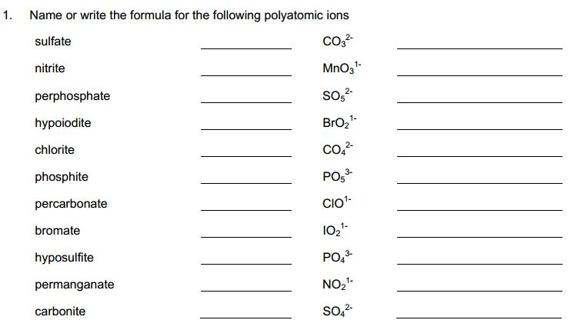



1. Describe what a polyatomic ion is
2. Provide the chemical formula for and draw a ball-and-stick model of the following polyatomic ions. The first one is done for you as an example.
   1. Nitrate



* 1. Hydroxide
  2. Sulfate
  3. Ammonium

1. Provide the chemical formula and name of the following polyatomic ions. The first one is done as an example for you.



2-

S



1. Write the formula for the following compound (remember they include polyatomic ions within the name)



