Segment of the Electromagnetic Spectrum | Description | Frequency | Wavelength | Examples
Electromagnetic Spectrum Name:_____________________________
- What is the electromagnetic spectrum?

- In the image below fill in the parts of the electromagnetic spectrum in their appropriate spots. The graphic organizer you filled out on the back may help

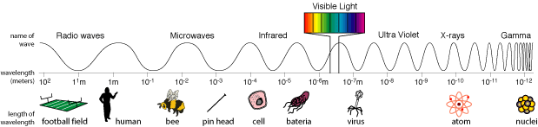

- Which part of the electromagnetic spectrum contains waves with the longest wavelength?_______________________________________
  - Describe the frequency of these waves.__________________________________________________________________________
  - Describe how the energy of these waves makes them capable of their uses. ______________________________________________________________________________________________________________________

- Which part of the electromagnetic spectrum contains waves with the shortest wavelength? _____________________________________
  - Describe the frequency of these waves._________________________________________________________________________
  - Describe how the energy of these waves makes them capable of their uses. ______________________________________________________________________________________________________________________

