Introduction
The Electromagnetic Spectrum is the range of all possible frequencies of electromagnetic radiation.^{[1]} The "Electromagnetic Spectrum" of an object has a different meaning, and is instead the characteristic distribution of electromagnetic radiation emitted or absorbed by that particular object.
The Electromagnetic Spectrum extends from below the low frequencies used for modern radio communication to gamma radiation at the short-wavelength (high-frequency) end, thereby covering wavelengths from thousands of kilometers down to a fraction of the size of an atom. The limit for long wavelengths is the size of the universe itself, while it is thought that the short wavelength limit is in the vicinity of the Planck length,^{[2]} Until the middle of last century it was believed by most physicists that this spectrum was infinite and continuous.
Most parts of the Electromagnetic Spectrum are used in science for spectroscopic and other probing interactions, as ways to study and characterize matter.^{[3]} In addition, radiation from various parts of the spectrum has found many other uses for communications and manufacturing.

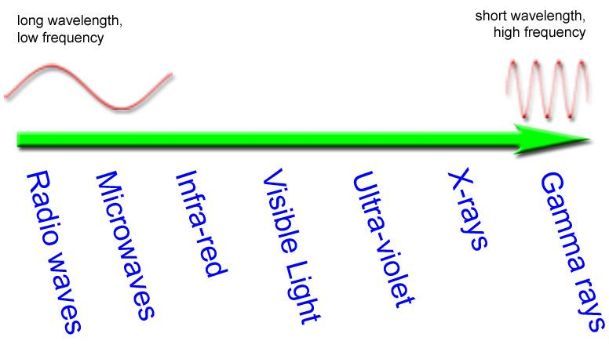

Instructions: Working alone, you will be assigned a specific region of the Electromagnetic Spectrum. At the end of this project your poster will be viewed by the class to pick out important information. Research your assigned area of the Electromagnetic Spectrum and create a poster. Posters must include the following:
Level 2
- Title – Name of the region of the Electromagnetic Spectrum assigned.
- Where is this type of radiation located on the Electromagnetic Spectrum in relation to other kinds of radiation? You need to draw the electromagnetic spectrum and highlight/circle your wave
- Characteristics of your type of radiation (wavelength, frequency, key facts).
- How is it used or found in our everyday lives or certain industries? Identify and explain at least two uses.
- Picture-showing how your wave is used
- Include one way in which your wave is harmful, explain.
- Include one way in which your wave is helpful, explain.
Level 3
- Why is your wave found in its specific location on the spectrum? Why is your wave not somewhere else?
- Explain how the uses listed above are related to the wavelength and frequency.

